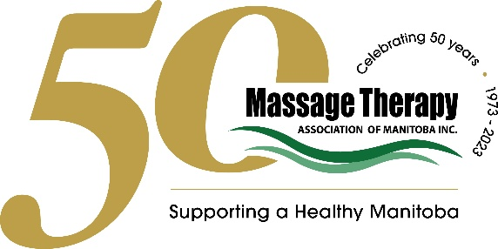

Subject: Request for the removal of the Physician Referral requirement

To Whom It May Concern,

Massage therapy is a non-invasive, effective way to manage pain, treat injuries, improve mobility, and help maintain employees’ overall health and wellbeing. Registered Massage Therapists (RMTs) are not only skilled and professional but also play a crucial role in supporting Manitobans’ healthcare needs.
The physician referral or doctor’s note requirement on health benefit plans creates unnecessary barriers for individuals wanting use their benefits to access massage therapy and other products and services on their health benefits plan.
To fulfill this requirement, employees must visit a walk-in clinic or schedule a doctor’s appointment and pay a fee to obtain the note. Both options cost the employee money and may require the employee to be away for several hours during the workday.
Doctors Manitoba estimates that physicians complete over 300,000 referrals for paramedical services, including massage therapy, every year. This takes over 49,000 hours of physician time, equivalent to nearly 150,000 patient visits annually. They have recommended removing physician authorization for paramedical benefits to free up physician time, and massage therapists agree with this. So does the insurance industry, which issued a national standard practice to remove physician referrals for paramedical benefits. Reference links have been included at the end of this letter which confirm this information.
By removing the doctor’s note requirement to access massage therapy in your company’s health benefit plan, it will remove unnecessary barriers for employees and help to prioritize their wellness.

I kindly request that you consider removing the doctor’s note requirement. If you need further information or have any questions, I encourage you to contact MTAM directly.
Thank you for considering this proposal.

Best regards,

Tricia Weidenbacher
Executive Director
Massage Therapy Association of Manitoba

References:
Doctors Manitoba study and recommendation: https://assets.doctorsmanitoba.ca/documents/ABTF-Recommendation-5-Paramedical.pdf
National insurance standard practice:
https://www.clhia.ca/web/clhia_lp4w_lnd_webstation.nsf/page/4E53475F7405451785258AA6005CEC58/$file/Standard%20best%20practices%20on%20referrals%20and%20prescriptions%20EN.pdf

